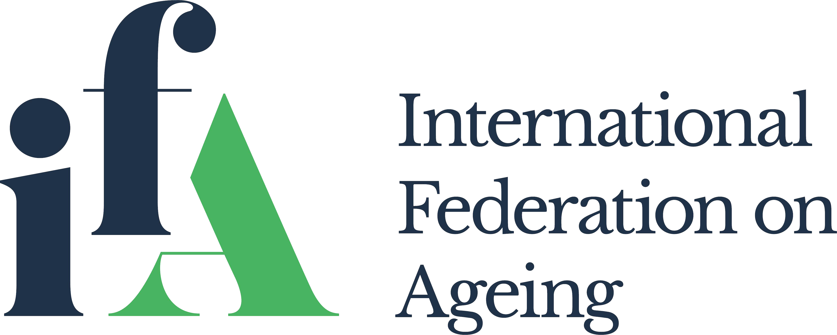

Internship Application

The International Federation on Ageing (IFA) offers internship opportunities to individuals with a broad variety of backgrounds and areas of interest.

Purpose of the Internship
The internship program offers a vehicle of learning on global ageing issues through involvement in our various projects. The IFA reaches individuals and organizations in ~80 countries and has general consultative status with the United Nations and its agencies, including the Economic and Social Council and the World Health Organization. Interns enjoy substantial opportunities for active involvement across the many levels of IFA’s operations.

Scope
The scope of the internship is directly related to the person’s experience and interests. Interns develop personal and professional goals, which are reviewed on a regular basis to facilitate skill-building, and undertake specific projects, including:
- Researching and writing articles on age-related policy and practice for the monthly IFA eNewsletter (VoltAGE)
- Contributing to IFA’s knowledge bank through active involvement in major international studies
- Participating in administrative tasks to better understand the operations of an international NGO
- Updating and enhancing the IFA website to better educate citizens, organizations, and governments around the world
- Meeting with local and regional NGOs and reporting back to IFA on opportunities for collaboration

Application Process
Please complete the questionnaire and submit your application, along with a cover letter and resumé or curriculum vitae, to Ms. Sneha Yatam, Accounts and Office Manager.

Internship Application Questionnaire

- How do your academic background and personal experiences serve IFA’s mission?

- Tell us why an internship at IFA is important to you personally and professionally.

- Describe any relevant experience that you bring to IFA.

- What are your goals for your time with IFA?

Thank you for applying for an internship position with the International Federation on Ageing.

